1. Chromatin consists of DNA and protein
2. Prior to cell division, each chromosome replicates or duplicates its genetic material. The resulting sister chromatids are connected by structure called centromere.
3. A nucleosome is a protein that DNA is wrapped around and compacted (B).

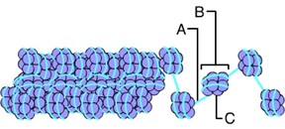

1. Which eukaryotic cell structure physically moves the cell’s chromosomes during cell division? The Mitotic spindle
2. The key enzyme responsible for replicating DNA is DNA polymerase.
3. The DNA strand being produced continuously in the 5` => 3` direction is called the leading strand.
4. Any change in the nucleotide sequence of DNA is called a mutation.
5. In a missense mutation the mutated codon causes a change in the amino acid specified.
6. A frameshift mutation could result from either an insertion or a deletion of a base.
7. An enzyme that “cuts” DNA at a specific sequence of nucleotide bases such as shown in the following figure is called restriction enzyme.

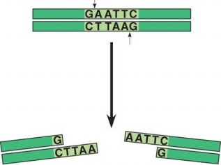

1. Which of the following are required to carry a PCR?
2. Gel electrophoresis separates DNA fragments on the basis of differences in their length.
3. The sequence of events from one cell division to the next describes the cell cycle.
4. S phase is part of the interphase of the cell cycle.
5. Chromosomes are duplicated during the S phase.
6. The correct sequence of the phases of mitosis is:

Prophase – Prometaphase – Metaphase – Anaphase – Telophase

1. Cytokinesis refers to division of the cytoplasm.
2. During cytokinesis, as shown in the following image, plant cells develop a cell plate instead of a cleavage furrow.

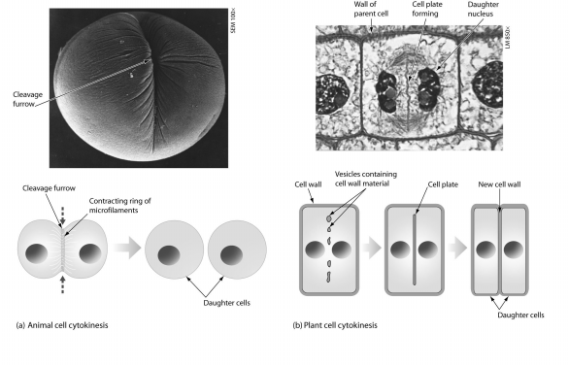

1. Apoptosis is also called programmed cell death.
2. Which of the following is not true about telomeres: They produce telomerase
3. Immune system cells, activated by an infection, will have a non-dividing phase and reenter the sequence of events in the cell cycle that leads to cell division. What would be the correct sequence of cell division?

G0, G1, s, G2, M

1. As a patch of scraped skin heals, the cells fill in the injured area but do not grow beyond that. This is an example of contact inhibition.
2. Cancer cells do not have contact inhibition and …
3. In order for a cell to become cancerous, oncogenes must be activated and tumor suppressors inactivated.
4. After a visit to a specialist, Dan was diagnosed with liver cancer. Six months later additional tumors were found in his stomach and small intestine. This is an example of metastasis.
5. It is essential the meiosis produce haploid cells to prevent the number of chromosomes from doubling each generation.
6. Homologous chromosomes refer to a pair of chromosomes that carry genes controlling same characters, one derived from the mother and the other from the father.
7. Which of the following is the order that most logically illustrate a sequence of meiosis?
8. Synapsis: Chromosomes moving towards the middle of the cell
9. Alignment of homologue pairs at the equator of cell
10. Separation of the homologue pairs
11. Separation of sister chromatids
12. Formation of four new nuclei, each with half the chromosomes present in the paternal nucleus
13. This s the start of meiosis II

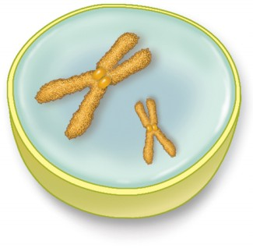

1. The best reason to conclude that a cell is in Anaphase II is that sister chromatids are separating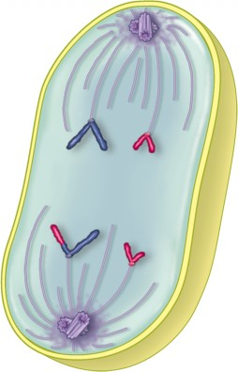
2. Meiosis I separates homologous pairs; meiosis II separates sister chromatids.
3. The meiotic stage represented by following diagrams for a cell with 2n=4 is A)anaphase I B) anaphase II

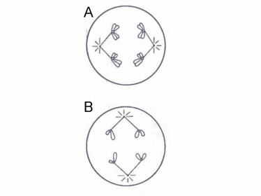

1. Mitosis results in the formation of two diploid cells; meiosis results in the formation of four haploid cells.
2. Key difference between meiosis and mitosis is that synapsis occurs.
3. Result of recombination (crossing over) during meiosis is: it creates chromosomes with new combinations of both parental and maternal alleles.
4. Genetic diversity is enhanced by random fertilization.
5. A karyotype (a chromosome display) would be unable to determine eye color.
6. Dawn syndrome can be the result of nondisjunction of chromosome 21 during meiosis
7. The exchange of genetic materials between non-homologous chromosomes is called translocation.
8. A leaf is green because chlorophyll molecules do not absorb green light.
9. The blue light photon has a wavelength of 475 nm, the orange light photon has a wavelength of 590 nm. Photons of the blue light (shorter wave length) carry more energy.
10. Only lights that can be absorbed are useful for photosynthesis.
11. Photosynthesis is driven by the visible light spectrum.
12. Based on the absorption spectrum of plant leaf pigments displayed below, if I want to grow some plants in a growth chamber located in a closet, a light bulb that emits a light wavelength of 430 nm would be best suited.

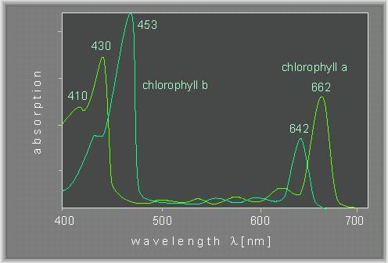

1. The O2 produced during photosynthesis comes from water.
2. Varieties of plants in which self-fertilization produces offspring that are identical to the parents are called true-breeding
3. In the study of genetics, the offspring of the P generation is referred to as the F1 generation.
4. Mendel called a trait that is masked recessive.
5. Genes often occur in alternative forms called alleles.
6. If the two alleles for a particular gene are identical, the gene pair is homozygous
7. The physical traits of an organism are its phenotype.
8. The most common phenotype in a population is referred to as the wild type.
9. The fact that 2 alleles of each gene are packed into separate gametes; that they move apart from each other during gamete formation is Mendel’s Law of segregation.
10. 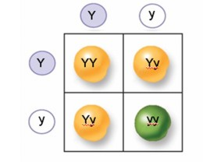The fat that during gamete formation, the segregation of alleles for a gene on one chromosome does not influence the segregation of alleles for a gene on another chromosome is Mendel’s Law of independent assortment.
11. This is a Punnett square:
12. A person with ABO blood illustrates the principal of co-dominance.
13. A child with genotype IAi has type A blood.
14. A single gene may affect more than one trait and this is called Pleiotropy.
15. The individual 1 shown in the following pedigree represents a normal female.

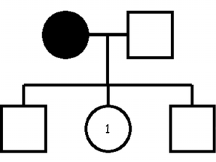

1. When thinking about cross-breeding and hybridization this is false:

The hybrid offspring of a cross are P1 generation.

Mandel crossed true-breeding purple-flowered plants with true-breeding white flowered plants, and all of the resulting offspring produced purple flowers. The allele for purple flowers is dominant.

1. If one allele is not phenotypically expressed in the presence of another, we say that it is a recessive allele.
2. A plant with the genotype AABbcc is homozygous at two loci.
3. In one plant, the alleles A, B, and C are completely dominant to the alleles A, b, and c. A plant with the genotype AABbcc will have the same phenotype as the plant with the genotype AaBBcc.
4. What do the letters we write in a Punnett table represent? The genotype of the offspring
5. In hamsters, black coat color (b) is dominant to white coat (b). A homozygous black hamster is mated with a heterozygous black hamster. What will be the genotypes and phenotypes of their offspring? BB or Bb – all black.
6. If an organism expresses the dominant phenotype it may carry a recessive allele.
7. This chart demonstrates that round eyes are dominant to vertical eyes; the absence of a tooth is dominant to presence of a tooth.

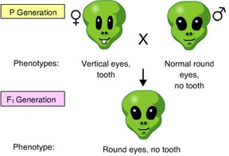

1. In a situation in which genes assort independently, what is the ration of the gametes produced by an AaBB individual? Ab : aB = 1:1
2. In peas, purple flower color P is dominant to white flower color p. suppose we have a pea plant with purple flowers. Hoe might you determine whether the plant is homozygous PP or heterozygous Pp? Perform a testcross: cross the plant with a true-breeding white flower plant.

|  |  |
| --- | --- |
| If it was PP crossed with pp | If it was Pp crossed with pp |
| |  |  | | --- | --- | | Pp | Pp | | Pp | Pp |   All flowers would be purple. | |  |  | | --- | --- | | Pp | Pp | | pp | pp |   Half of the flowers would be purple and half white. |

1. Martians have 3 possible genotypes and phenotypes for their antennas: long (AA), medium (Aa), and short (aa). This is the demonstration of incomplete dominance.
2. If your blood type is B and your father’s blood type is A, you conclude that the genotype of your blood type is IBi and your father’s is IAi .
3. If a mother has blood type O, which blood type could never occur in any of her children? AB
4. Marfan syndrome is the result of inheriting a single allele. Individuals with Marfan syndrome are tall and long-limbed, and have both cardiovascular and eye defects. The inheritance of Marfan syndrome is an example of pleiotropy.
5. A trait that is exhibited in varying range of degrees, such as height in humans, is an indication that the trait is due to the contribution of several genes, also known as polygenic inheritance.
6. The individual features of all organisms are result of genetic and the environment.
7. This pedigree supports the fact that widow’s peak is due to a dominant allele, because if it were due to a recessive allele and both parents show the recessive phenotype (Joseph and Alicia) all of the offsprings would have a widow’s peak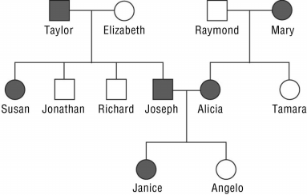
8. Widows peak is a genetic trait caused by a dominant allele (W) based on the pedigree analysis you deduced that Mary has genotype Ww. 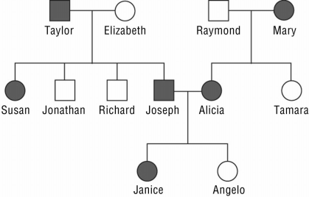
9. A dominant genetic disorder, such as Huntington’s disease, can occure in a homozygouse dominant genotype and heterozygous genotype.
10. I = Interphase II = Telophase III = Anaphase IV = Prophase V = Metaphase 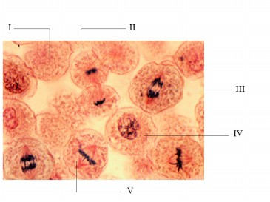
11. To read a set of human chromosomes, scientists use several key features to identify their similarities and differences. They are:
12. A karyotype is a photograph of all a person’s chromosomes.
13. Here is a karyotype with 47 chromosomes. The 3ed chromosome 21 is the sign of a genetic disease. It also shows that the individual is male.

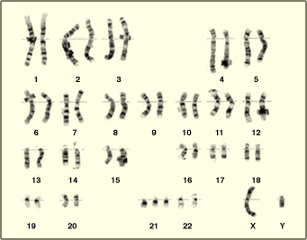

1. Linked genes are genes that are found on the same chromosome.
2. Diagram of gene order and spacing on chromosomes are Linked Maps.
3. Any gene located on a sex chromosome but has nothing to do with sex determination is called sex-linked gene.
4. A Barr body is an inactive X chromosome.
5. A gradual change from an ancestral type was referred to by Darwin as Descent with Modification.
6. Adaptation is a trait that is heritable and confers reproductive success.
7. Broccoli, Cabbages, and Brussels sprouts all descend from the same wild mustard. They were produced by artificial selection.
8. A population is a group of individuals of the same species living in the same place at the same time.
9. The entire collection of genes and their alleles is a population’s gene pool.
10. A change in allele frequencies in a population over generations is referred to as microevolution.
11. Which mechanisms can alter allele frequencies?
12. Movement of alleles from one population to another is called gene flow.
13. Random change in the genetic makeup of a population due to chance is genetic drift.
14. Bright plumes and long tail feathers of a male bird-of-paradise represent an example of sexual selection.
15. Here is a figure that describes the directional selection as a mode of natural selection:
16. 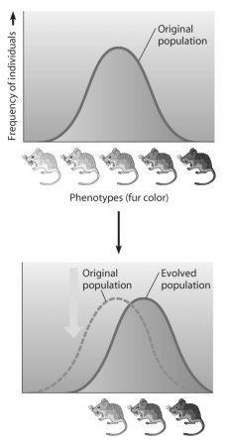If hair color, eye color, and freckles were consistently inherited together, the best explanation would be that the genes for these traits are linked.
17. Linked genes generally do not follow the laws of independent assortment.
18. Linked genes crossing over and independent assortment of unlinked genes are the mechanism for the production of genetic recombinants.
19. Sturtevant’s linkage map orders genes on a chromosome based on recombination frequencies.
20. Given the following recombination frequencies the order of these on the chromosome can be determined as: c----a-----b----d

a,c 10% a,d 30% b,c 24% b,d16%

1. Sex-linked conditions are more common in men then in women because men need to inherit only one copy of the recessive allele for the condition to be fully expressed.
2. Color blindness is an X-linked recessive trait. A color-blind man has a daughter with normal color vision. What is the genotype of the daughter? XCXc
3. A girl born to a couple has inherited hemophilia A an x-linked recessive genetic disorder. We can deduce that her parents would have this genotype: XHXh, XhY
4. Anhidrotic ectodermal dysplasia is an X-linked disorder that results in the absence of sweat glands. This condition manifests in a heterozygous female: she would have a random pattern of tissue with and without sweat glands due to X-inactivation.
5. Natural selection is differential reproductive success based on inherited characteristic.
6. The ease with which humans travel across the globe is likely to increase gene flow.
7. Genetic drift is a process based of the role of chance.
8. It is WRONG to say: the north American bison was hunted to near extinction in 1800s, and has since recovered, but with decreased genetic diversity. This is an example of stabilizing selection.
9. Sexual dimorphic features do not include Intelligence.
10. The use of herbicides and pesticides over many years has led to resistance in many organisms. This is directional selection.
11. There are no fitness differences among individuals with different fingerprints. The term that best describes this situation is natural variation.
12. Ty-Sach in inherited as an autosomal recessive allele. Homozygous individuals die within the first few years of life. However, there is some evidence that heterozygous individuals are more resistant to tuberculosis. This situation is an example of heterozygous advantage if tuberculosis is present in population.
13. Genetic drift and natural selection generate variation in population.
14. DNA fingerprinting is a test used to identify genetic information in a person’s cell.
15. Gel electrophoresis is used to separate DNA fragments.
16. The electrical charges of the DNA’s phosphate groups cause it to move through a gel during electrophoresis.
17. Longer DNA fragments migrate slower than shorter fragments.
18. A segment of DNA has 2 restriction sites – I and II. When incubated with restriction enzymes I and II, three fragments will be formed –a, b, and c. gel B represents the separation and identity of these fragments. 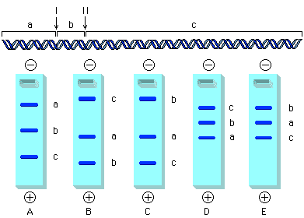
19. The term “RFLP” refers to the fact that restriction enzymes cut DNA into pieces of different length.
20. The letters C and D indicate restriction sites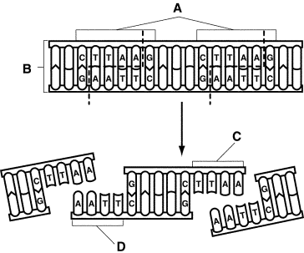
21. DNA fingerprints used as evidence in a murder trial look something like supermarket bar codes. The pattern of bars in a DNA fingerprint shows the presence of various-size fragments of DNA.
22. Correct order of steps in DNA analysis is:
23. Loading samples
24. Electrophoresis
25. Visualization
26. Suspect 2 here matches the samples taken at the crime scene
27. 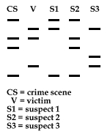The types of living organisms on Earth have changed over time, new species have originated and existing species have disappeared. This is an example of macroevolution.
28. The biological species concept is based on reproductive isolation.
29. Biologists divide mechanisms of reproductive isolation into Pre-zygotic and Post-zygotic
30. Hybrid infertility is not a type of pre-zygotic reproductive isolation.
31. In mechanical isolation sex organs are not compatible.
32. Gamete incompatibility is resulted from the fact that sperm and egg are unable to bind.
33. The spatial arrangements that may help cause speciation are: Sympatric, Parapatric, and allopatric.
34. Allopatric speciation is the separation of two species by physical barrier.
35. In plants, polyploidy can lead to sympatric speciation.
36. Number II is an example of polyploidy:
37. An insect with n=4 has 8 total chromosomes in each somatic cell
38. A plant with n=12 has 48 total chromosomes in each somatic cell
39. A fish with n=66 has 132 total chromosomes in each somatic cell
40. The idea that evolution proceeds in small, incremental changes over many generations is gradualism.
41. The hallmarks of punctuated equilibrium are periods of rapid change followed by stable periods.
42. Max extinctions create conditions that promote adaptive radiation.
43. Stanly Miller’s experiment produced amino acids molecules.
44. Oxygen (O2) was probably absent from the Earth’s primitive atmosphere.
45. The endosymbiont theory explains the origin of Mitochondria and chloroplasts.